34.43: a) A real image is formed at the film, so the lens must be convex.
b) 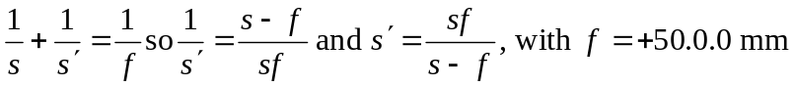
For
For 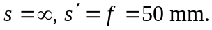
The range of distances between the lens and film is 